PUBLICATION: | Al Messa
DATE: | 23-Janaury-2013
COUNTRY: | Egypt
CIRCULATION: | 20,000
TITLE : | Transparency needed from pharmacists’ end
PAGE: | 10
ARTICLE TYPE: | Syndicate News
REPORTER: | Mohamed Fouad
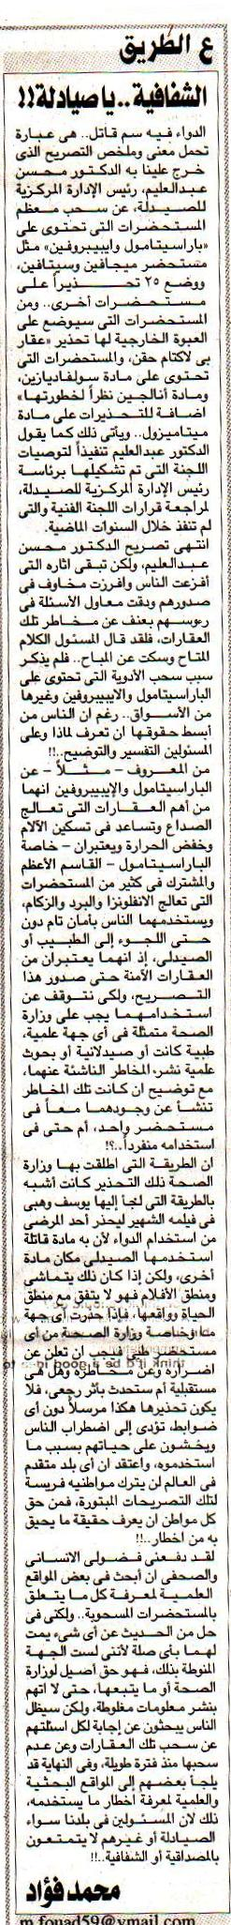

Translation

Dr. Mohsen Abdul Aleem, Head of the Central Pharmacy Affairs Department announced pulling off most drugs that contain “Paracetamol” and “Ibuprofen”, such as “Megafen” and “Cetafen”. In addition, 25 medical alerts were posted on other drugs, such as “β-lactam”, and medicines that contain “sulphadiazine”, “Metamizole” and “Analgin” due to their risk.

Dr. Mohsen’s announcement stirred people’s fears, as he announced the decision of pulling off these drugs but he never talked about the risks and what exactly such drugs do. People have the right to know everything about these drugs; the “Paracetamol” for example is commonly used even without physicians’ recommendations.

