


Top Stories Report
04 July 2013
Conventional
Competitors’ News

Publication | Al Ahram |  |  |  |  |  |  | Circulation |  | 900,000
Date: | 09- September -2019 |  |  |  |  |  |  | Frequency |  | Daily
Page (s) | 03
Placement Rating | -2 | -2 | -1 | -2 | -1 |  | 0 |  | +1 |  | +2 | +1 | +2 | +2
 | Premium Page | Quote | Picture | Name in Headline |  | Branded | Not Branded |  | Branded |  | Name in Headline | Picture | Quote | Premium Page
Publication’s Rating | A B C
Impact | +7A
Headline

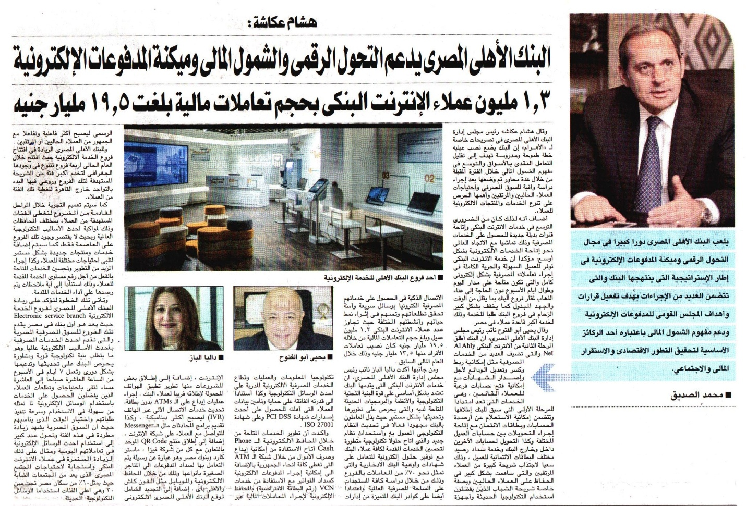

Publication | Al Ahram |  |  |  |  |  |  | Circulation |  | 900,000
Date: | 09- September -2019 |  |  |  |  |  |  | Frequency |  | Daily
Page (s) | 04
Placement Rating | -2 | -2 | -1 | -2 | -1 |  | 0 |  | +1 |  | +2 | +1 | +2 | +2
 | Premium Page | Quote | Picture | Name in Headline |  | Branded | Not Branded |  | Branded |  | Name in Headline | Picture | Quote | Premium Page
Publication’s Rating | A B C
Impact | +7A
Headline

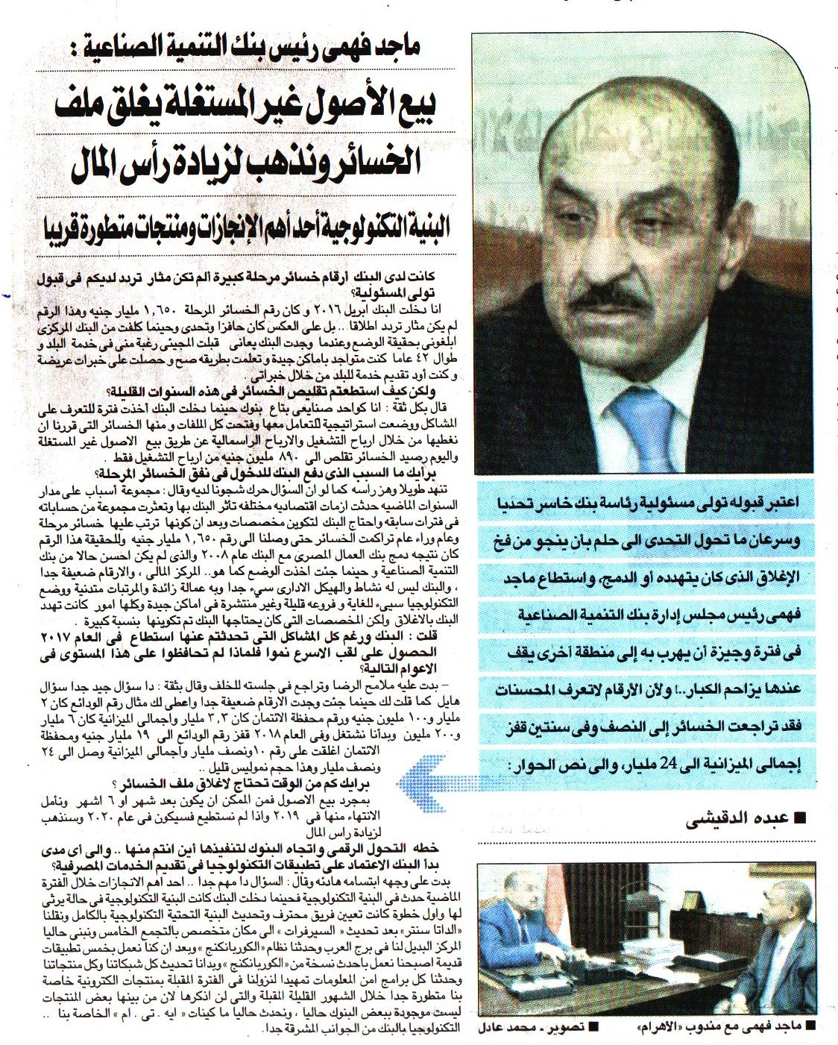

Publication | Al Ahram |  |  |  |  |  |  | Circulation |  | 900,000
Date: | 09- September -2019 |  |  |  |  |  |  | Frequency |  | Daily
Page (s) | 04
Placement Rating | -2 | -2 | -1 | -2 | -1 |  | 0 |  | +1 |  | +2 | +1 | +2 | +2
 | Premium Page | Quote | Picture | Name in Headline |  | Branded | Not Branded |  | Branded |  | Name in Headline | Picture | Quote | Premium Page
Publication’s Rating | A B C
Impact | +7A
Headline

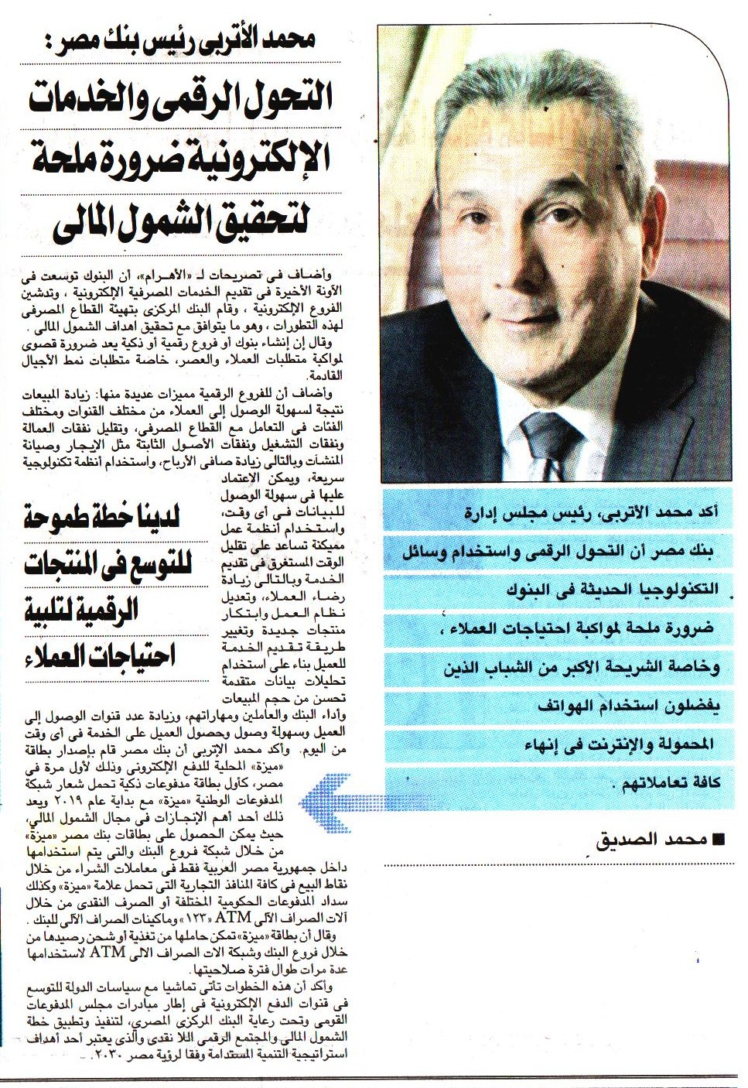

Publication | Al Ahram |  |  |  |  |  |  | Circulation |  | 900,000
Date: | 09- September -2019 |  |  |  |  |  |  | Frequency |  | Daily
Page (s) | 08
Placement Rating | -2 | -2 | -1 | -2 | -1 |  | 0 |  | +1 |  | +2 | +1 | +2 | +2
 | Premium Page | Quote | Picture | Name in Headline |  | Branded | Not Branded |  | Branded |  | Name in Headline | Picture | Quote | Premium Page
Publication’s Rating | A B C
Impact | +7A
Headline

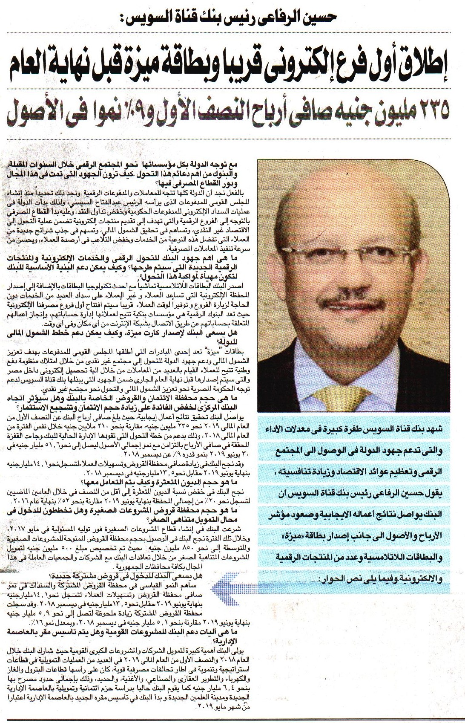

Publication | Al Ahram |  |  |  |  |  |  | Circulation |  | 900,000
Date: | 09- September -2019 |  |  |  |  |  |  | Frequency |  | Daily
Page (s) | 08
Placement Rating | -2 | -2 | -1 | -2 | -1 |  | 0 |  | +1 |  | +2 | +1 | +2 | +2
 | Premium Page | Quote | Picture | Name in Headline |  | Branded | Not Branded |  | Branded |  | Name in Headline | Picture | Quote | Premium Page
Publication’s Rating | A B C
Impact | +7A
Headline

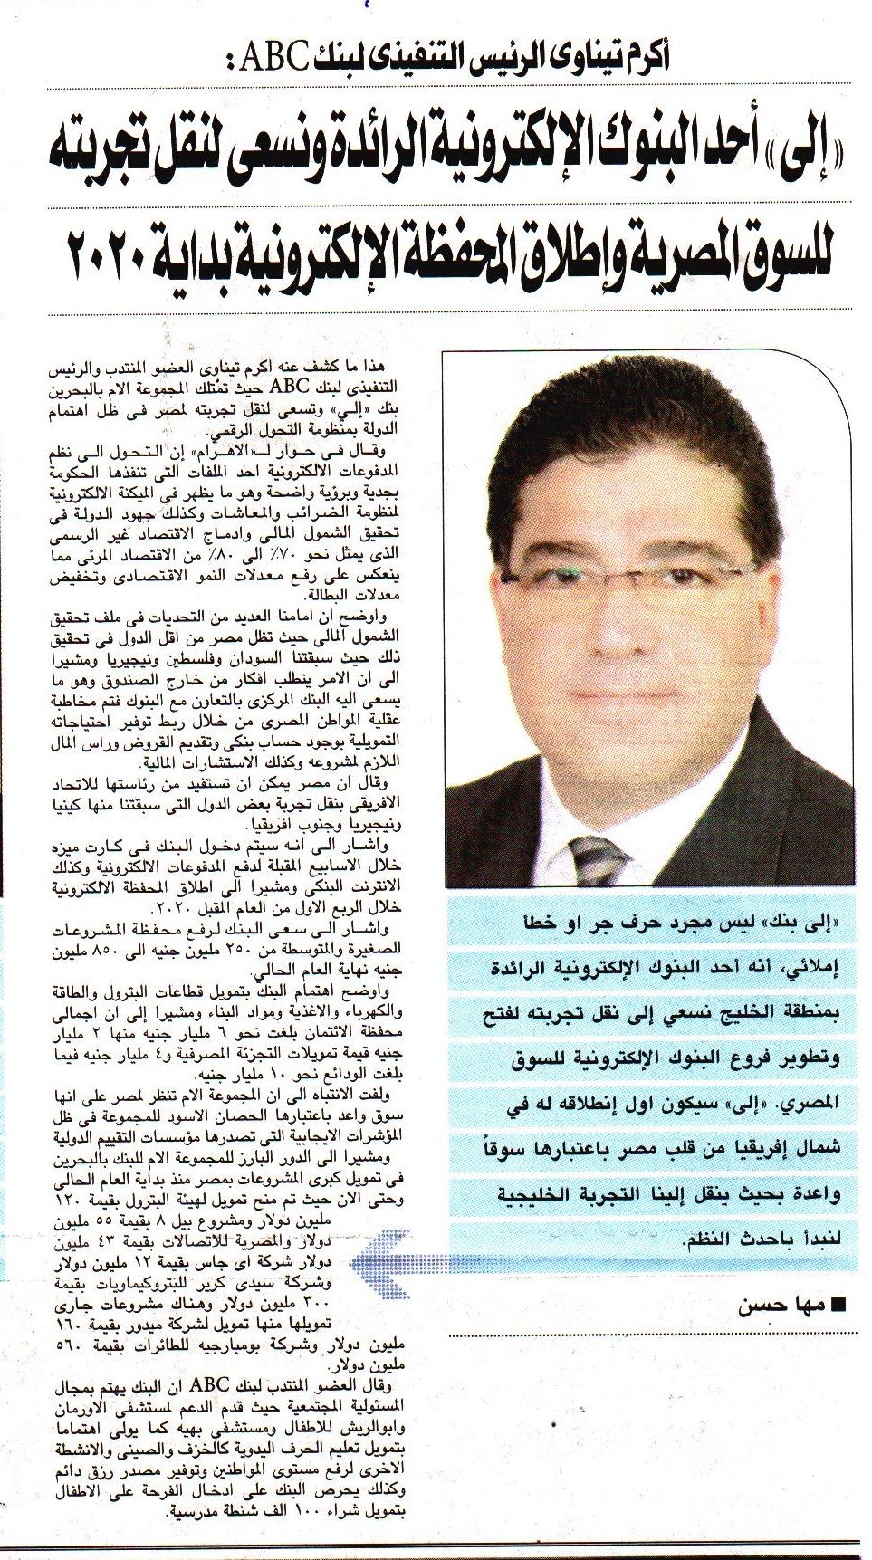

Publication | Al Ahram |  |  |  |  |  |  | Circulation |  | 900,000
Date: | 09- September -2019 |  |  |  |  |  |  | Frequency |  | Daily
Page (s) | 09
Placement Rating | -2 | -2 | -1 | -2 | -1 |  | 0 |  | +1 |  | +2 | +1 | +2 | +2
 | Premium Page | Quote | Picture | Name in Headline |  | Branded | Not Branded |  | Branded |  | Name in Headline | Picture | Quote | Premium Page
Publication’s Rating | A B C
Impact | +7A
Headline

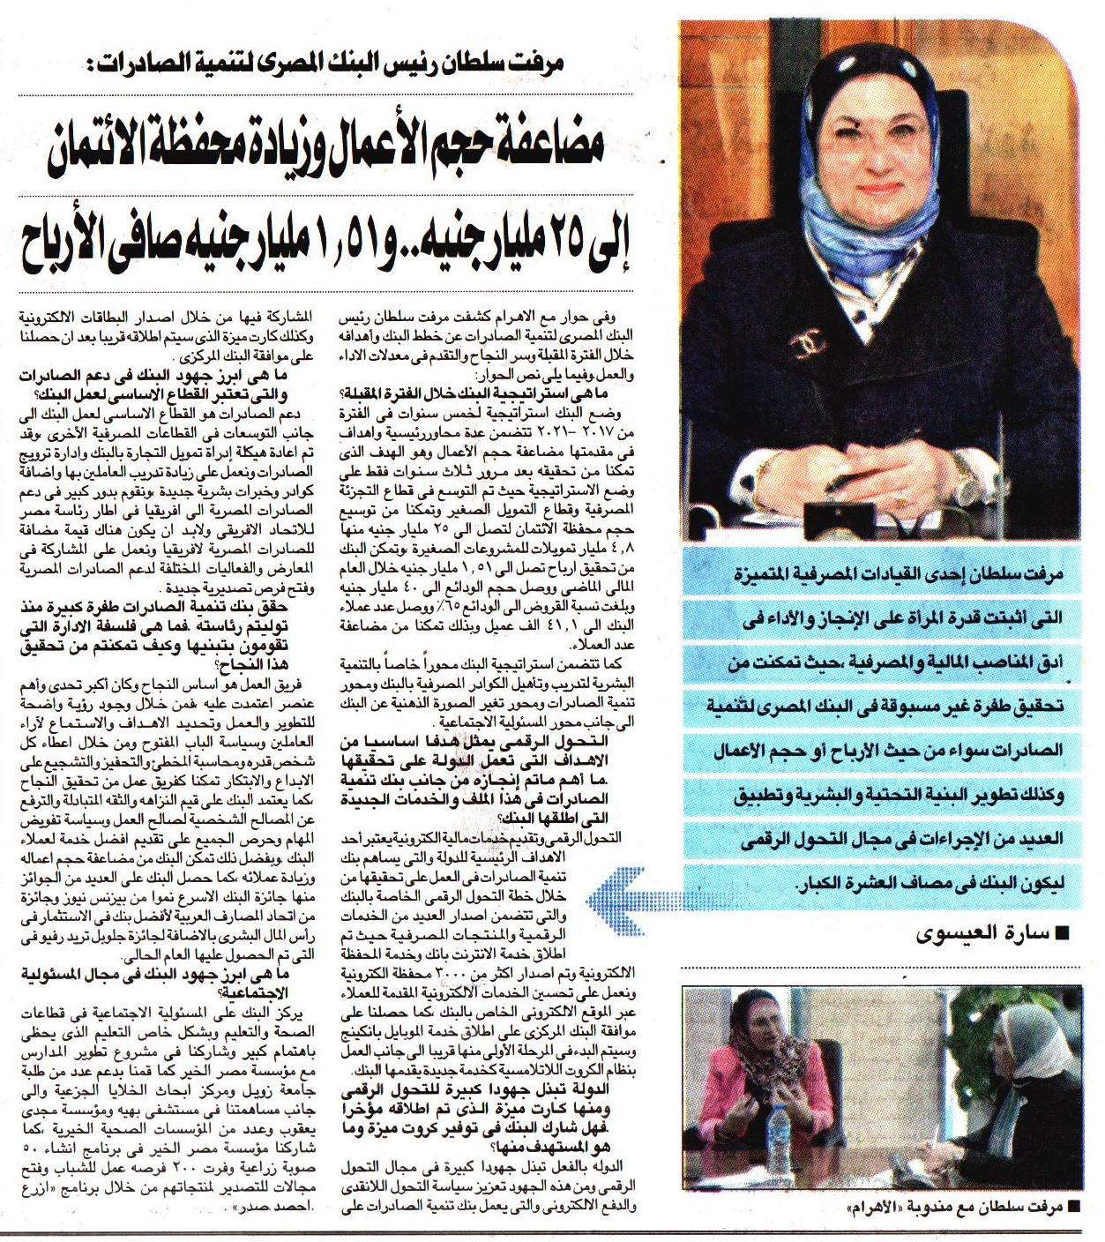

Publication | Al Ahram |  |  |  |  |  |  | Circulation |  | 900,000
Date: | 09- September -2019 |  |  |  |  |  |  | Frequency |  | Daily
Page (s) | 10
Placement Rating | -2 | -2 | -1 | -2 | -1 |  | 0 |  | +1 |  | +2 | +1 | +2 | +2
 | Premium Page | Quote | Picture | Name in Headline |  | Branded | Not Branded |  | Branded |  | Name in Headline | Picture | Quote | Premium Page
Publication’s Rating | A B C
Impact | +7A
Headline



Publication | Al Ahram |  |  |  |  |  |  | Circulation |  | 900,000
Date: | 09- September -2019 |  |  |  |  |  |  | Frequency |  | Daily
Page (s) | 11
Placement Rating | -2 | -2 | -1 | -2 | -1 |  | 0 |  | +1 |  | +2 | +1 | +2 | +2
 | Premium Page | Quote | Picture | Name in Headline |  | Branded | Not Branded |  | Branded |  | Name in Headline | Picture | Quote | Premium Page
Publication’s Rating | A B C
Impact | +7A
Headline

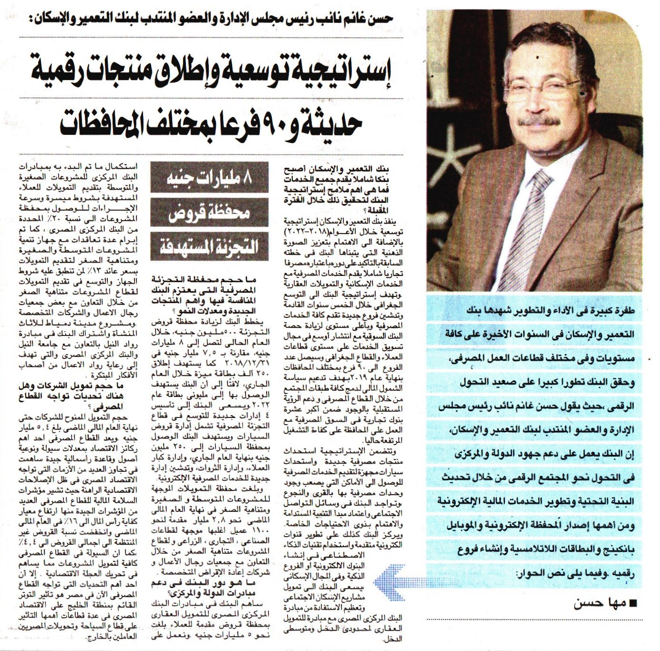

Publication | Al Alam Al Youm |  |  |  |  |  |  | Circulation |  | 50,000
Date: | 09- September -2019 |  |  |  |  |  |  | Frequency |  | Daily
Page (s) | 05
Placement Rating | -2 | -2 | -1 | -2 | -1 |  | 0 |  | +1 |  | +2 | +1 | +2 | +2
 | Premium Page | Quote | Picture | Name in Headline |  | Branded | Not Branded |  | Branded |  | Name in Headline | Picture | Quote | Premium Page
Publication’s Rating | A B C
Impact | +7A
Headline


Publication | Al Alam Al Youm |  |  |  |  |  |  | Circulation |  | 50,000
Date: | 09- September -2019 |  |  |  |  |  |  | Frequency |  | Daily
Page (s) | 05
Placement Rating | -2 | -2 | -1 | -2 | -1 |  | 0 |  | +1 |  | +2 | +1 | +2 | +2
 | Premium Page | Quote | Picture | Name in Headline |  | Branded | Not Branded |  | Branded |  | Name in Headline | Picture | Quote | Premium Page
Publication’s Rating | A B C
Impact | +7A
Headline

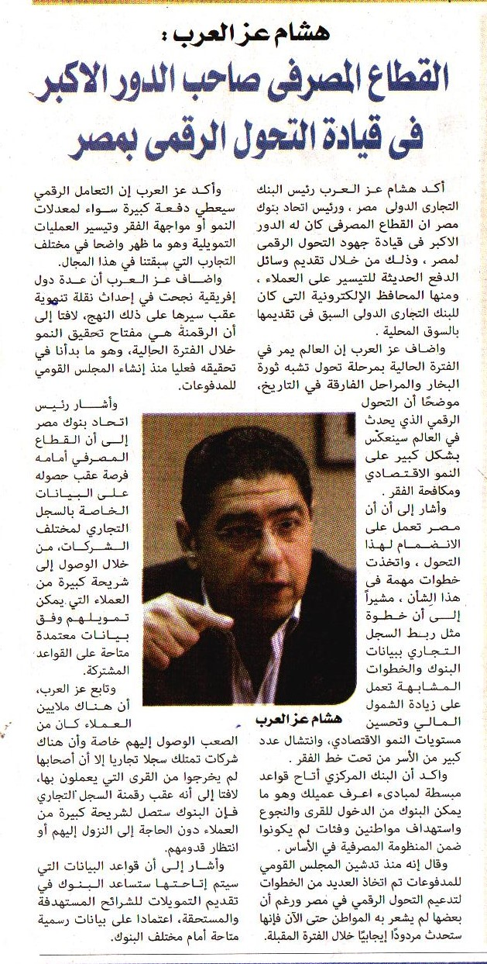

Publication | Al Alam Al Youm |  |  |  |  |  |  | Circulation |  | 50,000
Date: | 09- September -2019 |  |  |  |  |  |  | Frequency |  | Daily
Page (s) | 05
Placement Rating | -2 | -2 | -1 | -2 | -1 |  | 0 |  | +1 |  | +2 | +1 | +2 | +2
 | Premium Page | Quote | Picture | Name in Headline |  | Branded | Not Branded |  | Branded |  | Name in Headline | Picture | Quote | Premium Page
Publication’s Rating | A B C
Impact | +7A
Headline

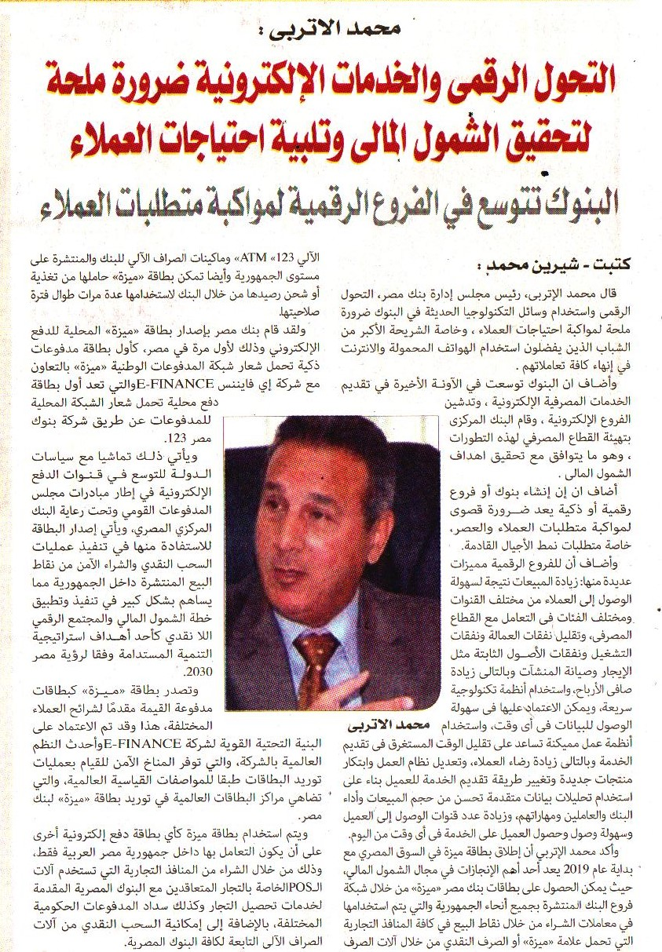

Publication | Al Alam Al Youm |  |  |  |  |  |  | Circulation |  | 50,000
Date: | 09- September -2019 |  |  |  |  |  |  | Frequency |  | Daily
Page (s) | 06
Placement Rating | -2 | -2 | -1 | -2 | -1 |  | 0 |  | +1 |  | +2 | +1 | +2 | +2
 | Premium Page | Quote | Picture | Name in Headline |  | Branded | Not Branded |  | Branded |  | Name in Headline | Picture | Quote | Premium Page
Publication’s Rating | A B C
Impact | +7A
Headline

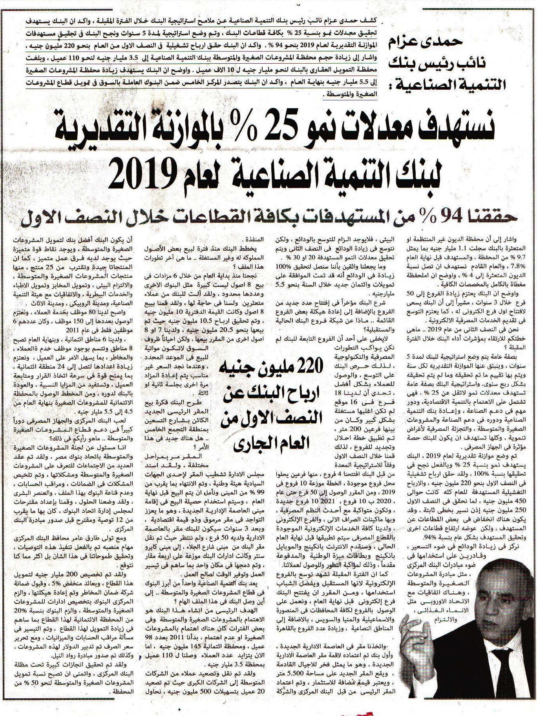

Publication | Al Alam Al Youm |  |  |  |  |  |  | Circulation |  | 50,000
Date: | 09- September -2019 |  |  |  |  |  |  | Frequency |  | Daily
Page (s) | 06
Placement Rating | -2 | -2 | -1 | -2 | -1 |  | 0 |  | +1 |  | +2 | +1 | +2 | +2
 | Premium Page | Quote | Picture | Name in Headline |  | Branded | Not Branded |  | Branded |  | Name in Headline | Picture | Quote | Premium Page
Publication’s Rating | A B C
Impact | +7A
Headline



Publication | Al Alam Al Youm |  |  |  |  |  |  | Circulation |  | 50,000
Date: | 09- September -2019 |  |  |  |  |  |  | Frequency |  | Daily
Page (s) | 06
Placement Rating | -2 | -2 | -1 | -2 | -1 |  | 0 |  | +1 |  | +2 | +1 | +2 | +2
 | Premium Page | Quote | Picture | Name in Headline |  | Branded | Not Branded |  | Branded |  | Name in Headline | Picture | Quote | Premium Page
Publication’s Rating | A B C
Impact | +7A
Headline

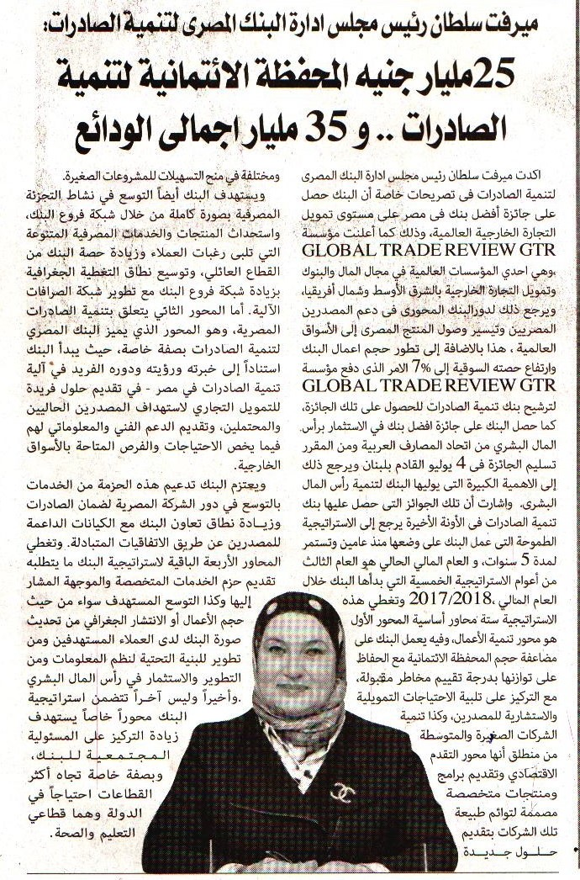

Publication | Al Alam Al Youm |  |  |  |  |  |  | Circulation |  | 50,000
Date: | 09- September -2019 |  |  |  |  |  |  | Frequency |  | Daily
Page (s) | 06
Placement Rating | -2 | -2 | -1 | -2 | -1 |  | 0 |  | +1 |  | +2 | +1 | +2 | +2
 | Premium Page | Quote | Picture | Name in Headline |  | Branded | Not Branded |  | Branded |  | Name in Headline | Picture | Quote | Premium Page
Publication’s Rating | A B C
Impact | +7A
Headline

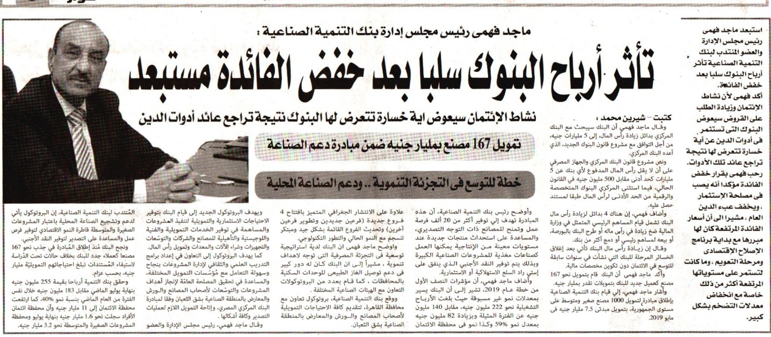

Publication | Al Alam Al Youm |  |  |  |  |  |  | Circulation |  | 50,000
Date: | 09- September -2019 |  |  |  |  |  |  | Frequency |  | Daily
Page (s) | 07
Placement Rating | -2 | -2 | -1 | -2 | -1 |  | 0 |  | +1 |  | +2 | +1 | +2 | +2
 | Premium Page | Quote | Picture | Name in Headline |  | Branded | Not Branded |  | Branded |  | Name in Headline | Picture | Quote | Premium Page
Publication’s Rating | A B C
Impact | +7A
Headline

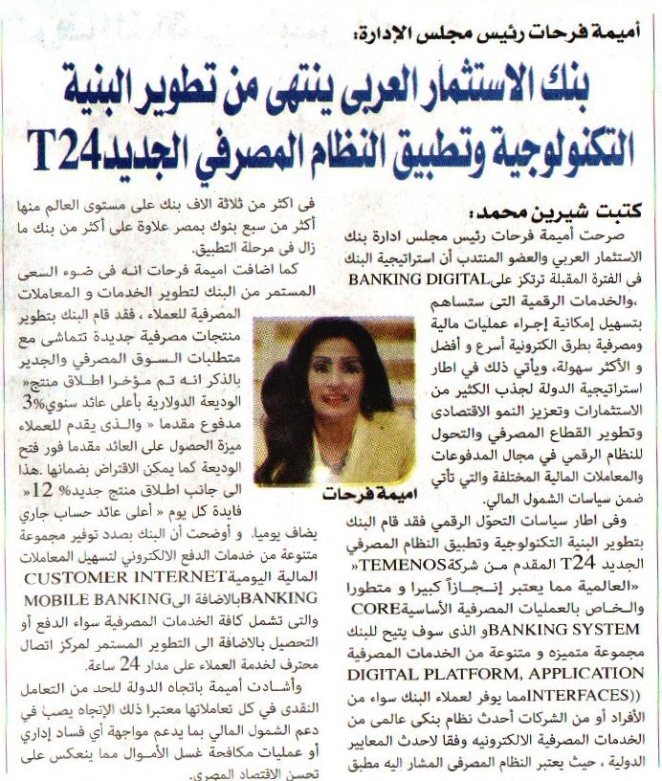

Publication | Al Alam Al Youm |  |  |  |  |  |  | Circulation |  | 50,000
Date: | 09- September -2019 |  |  |  |  |  |  | Frequency |  | Daily
Page (s) | 07
Placement Rating | -2 | -2 | -1 | -2 | -1 |  | 0 |  | +1 |  | +2 | +1 | +2 | +2
 | Premium Page | Quote | Picture | Name in Headline |  | Branded | Not Branded |  | Branded |  | Name in Headline | Picture | Quote | Premium Page
Publication’s Rating | A B C
Impact | +7A
Headline

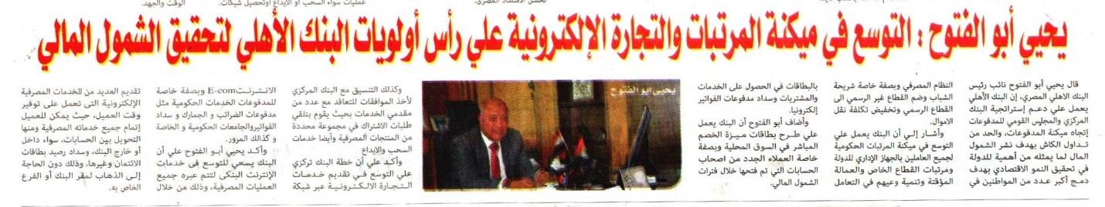

Publication | Al Alam Al Youm |  |  |  |  |  |  | Circulation |  | 50,000
Date: | 09- September -2019 |  |  |  |  |  |  | Frequency |  | Daily
Page (s) | 07
Placement Rating | -2 | -2 | -1 | -2 | -1 |  | 0 |  | +1 |  | +2 | +1 | +2 | +2
 | Premium Page | Quote | Picture | Name in Headline |  | Branded | Not Branded |  | Branded |  | Name in Headline | Picture | Quote | Premium Page
Publication’s Rating | A B C
Impact | +7A
Headline

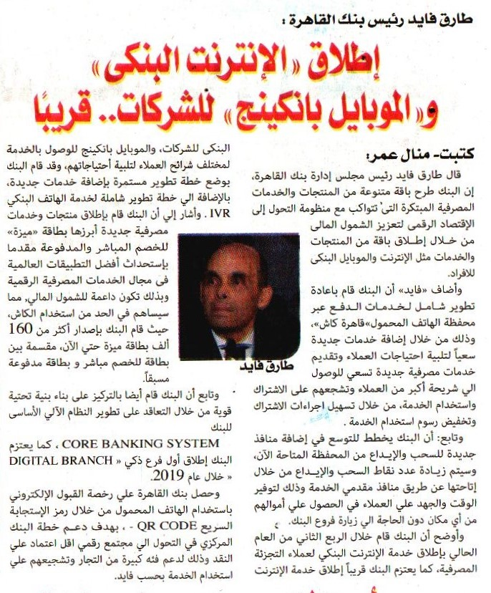

Publication | Al Alam Al Youm |  |  |  |  |  |  | Circulation |  | 50,000
Date: | 09- September -2019 |  |  |  |  |  |  | Frequency |  | Daily
Page (s) | 09
Placement Rating | -2 | -2 | -1 | -2 | -1 |  | 0 |  | +1 |  | +2 | +1 | +2 | +2
 | Premium Page | Quote | Picture | Name in Headline |  | Branded | Not Branded |  | Branded |  | Name in Headline | Picture | Quote | Premium Page
Publication’s Rating | A B C
Impact | +7A
Headline

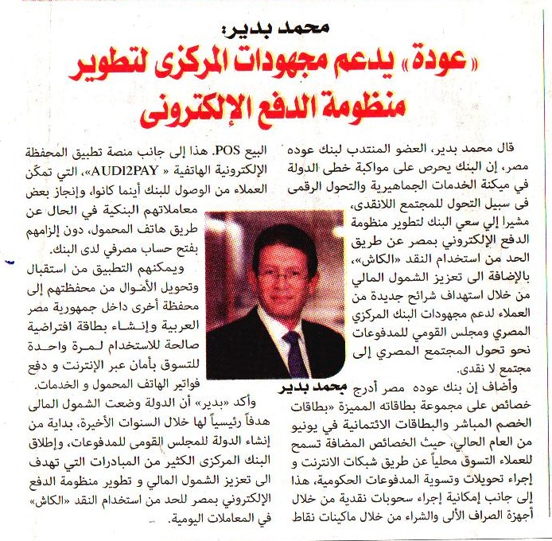

Publication | Al Alam Al Youm |  |  |  |  |  |  | Circulation |  | 50,000
Date: | 09- September -2019 |  |  |  |  |  |  | Frequency |  | Daily
Page (s) | 09
Placement Rating | -2 | -2 | -1 | -2 | -1 |  | 0 |  | +1 |  | +2 | +1 | +2 | +2
 | Premium Page | Quote | Picture | Name in Headline |  | Branded | Not Branded |  | Branded |  | Name in Headline | Picture | Quote | Premium Page
Publication’s Rating | A B C
Impact | +7A
Headline

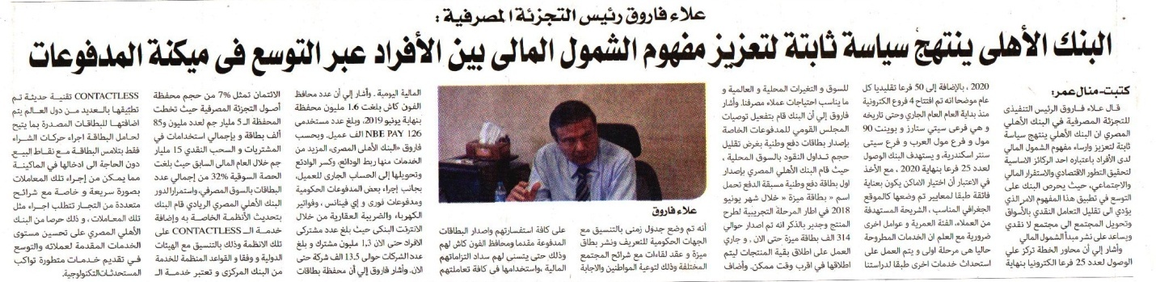

Publication | Al Alam Al Youm |  |  |  |  |  |  | Circulation |  | 50,000
Date: | 09- September -2019 |  |  |  |  |  |  | Frequency |  | Daily
Page (s) | 09
Placement Rating | -2 | -2 | -1 | -2 | -1 |  | 0 |  | +1 |  | +2 | +1 | +2 | +2
 | Premium Page | Quote | Picture | Name in Headline |  | Branded | Not Branded |  | Branded |  | Name in Headline | Picture | Quote | Premium Page
Publication’s Rating | A B C
Impact | +7A
Headline

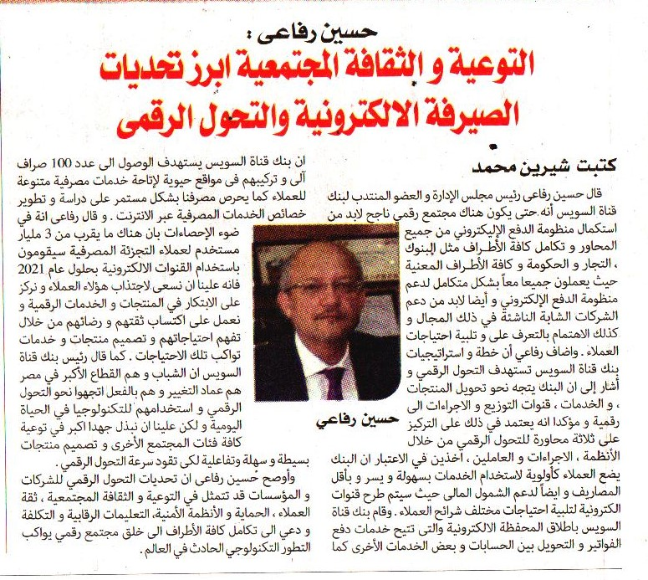

Publication | Al Alam Al Youm |  |  |  |  |  |  | Circulation |  | 50,000
Date: | 09- September -2019 |  |  |  |  |  |  | Frequency |  | Daily
Page (s) | 10
Placement Rating | -2 | -2 | -1 | -2 | -1 |  | 0 |  | +1 |  | +2 | +1 | +2 | +2
 | Premium Page | Quote | Picture | Name in Headline |  | Branded | Not Branded |  | Branded |  | Name in Headline | Picture | Quote | Premium Page
Publication’s Rating | A B C
Impact | +7A
Headline

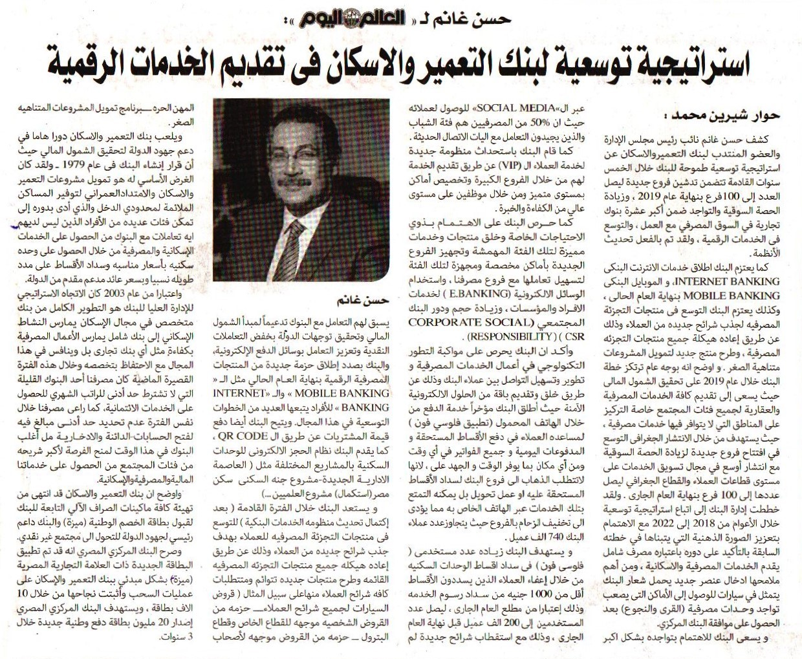

Publication | Al Alam Al Youm |  |  |  |  |  |  | Circulation |  | 50,000
Date: | 09- September -2019 |  |  |  |  |  |  | Frequency |  | Daily
Page (s) | 10
Placement Rating | -2 | -2 | -1 | -2 | -1 |  | 0 |  | +1 |  | +2 | +1 | +2 | +2
 | Premium Page | Quote | Picture | Name in Headline |  | Branded | Not Branded |  | Branded |  | Name in Headline | Picture | Quote | Premium Page
Publication’s Rating | A B C
Impact | +7A
Headline

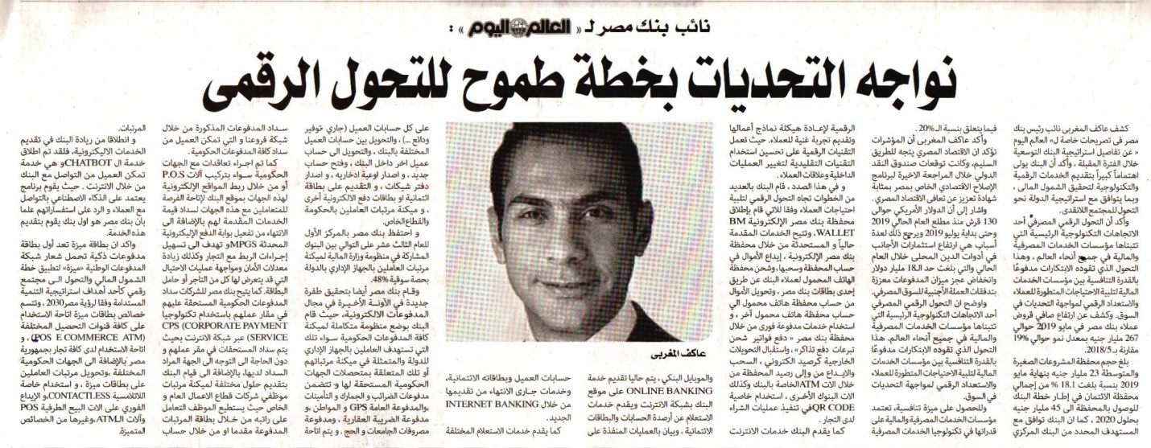

Publication | Al Alam Al Youm |  |  |  |  |  |  | Circulation |  | 50,000
Date: | 09- September -2019 |  |  |  |  |  |  | Frequency |  | Daily
Page (s) | 10
Placement Rating | -2 | -2 | -1 | -2 | -1 |  | 0 |  | +1 |  | +2 | +1 | +2 | +2
 | Premium Page | Quote | Picture | Name in Headline |  | Branded | Not Branded |  | Branded |  | Name in Headline | Picture | Quote | Premium Page
Publication’s Rating | A B C
Impact | +7A
Headline

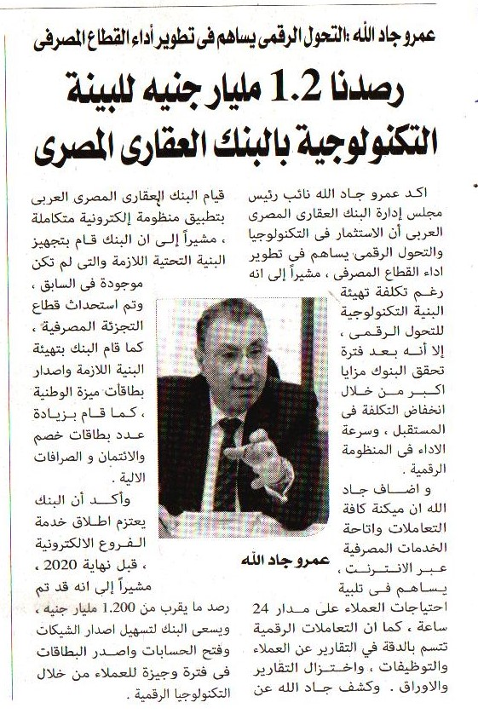

Publication | Al Alam Al Youm |  |  |  |  |  |  | Circulation |  | 50,000
Date: | 09- September -2019 |  |  |  |  |  |  | Frequency |  | Daily
Page (s) | 10
Placement Rating | -2 | -2 | -1 | -2 | -1 |  | 0 |  | +1 |  | +2 | +1 | +2 | +2
 | Premium Page | Quote | Picture | Name in Headline |  | Branded | Not Branded |  | Branded |  | Name in Headline | Picture | Quote | Premium Page
Publication’s Rating | A B C
Impact | +7A
Headline

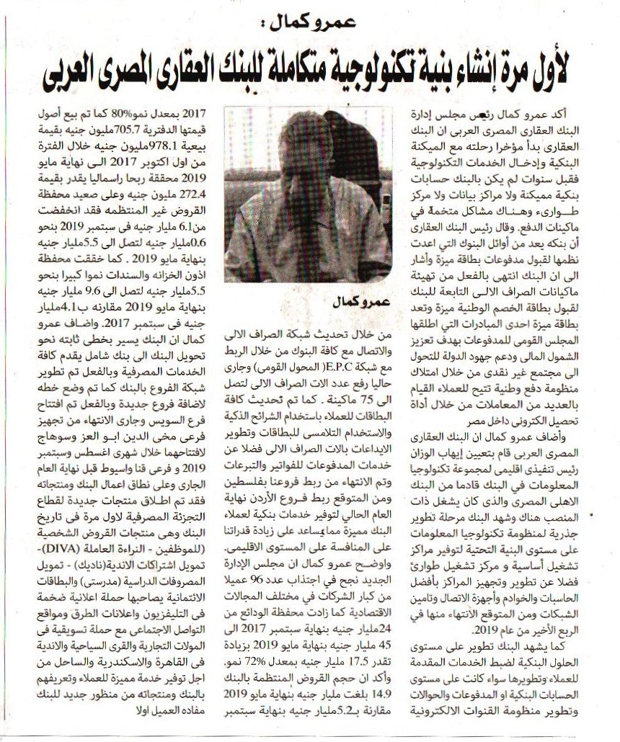

Publication | Al Alam Al Youm |  |  |  |  |  |  | Circulation |  | 50,000
Date: | 09- September -2019 |  |  |  |  |  |  | Frequency |  | Daily
Page (s) | 12
Placement Rating | -2 | -2 | -1 | -2 | -1 |  | 0 |  | +1 |  | +2 | +1 | +2 | +2
 | Premium Page | Quote | Picture | Name in Headline |  | Branded | Not Branded |  | Branded |  | Name in Headline | Picture | Quote | Premium Page
Publication’s Rating | A B C
Impact | +6A
Headline

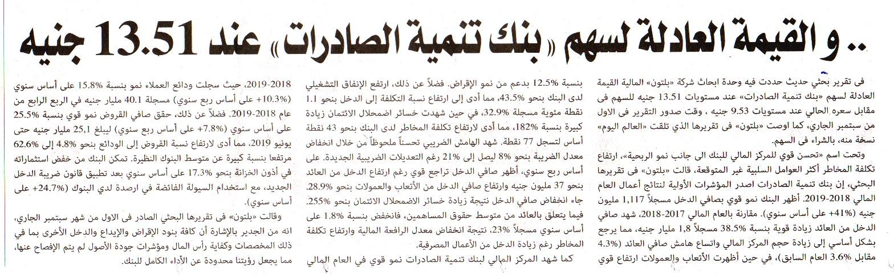

Publication | Al Gomhoureya |  |  |  |  |  |  | Circulation |  | 200,000
Date: | 09- September -2019 |  |  |  |  |  |  | Frequency |  | Daily
Page (s) | 18
Placement Rating | -2 | -2 | -1 | -2 | -1 |  | 0 |  | +1 |  | +2 | +1 | +2 | +2
 | Premium Page | Quote | Picture | Name in Headline |  | Branded | Not Branded |  | Branded |  | Name in Headline | Picture | Quote | Premium Page
Publication’s Rating | A B C
Impact | +7A
Headline

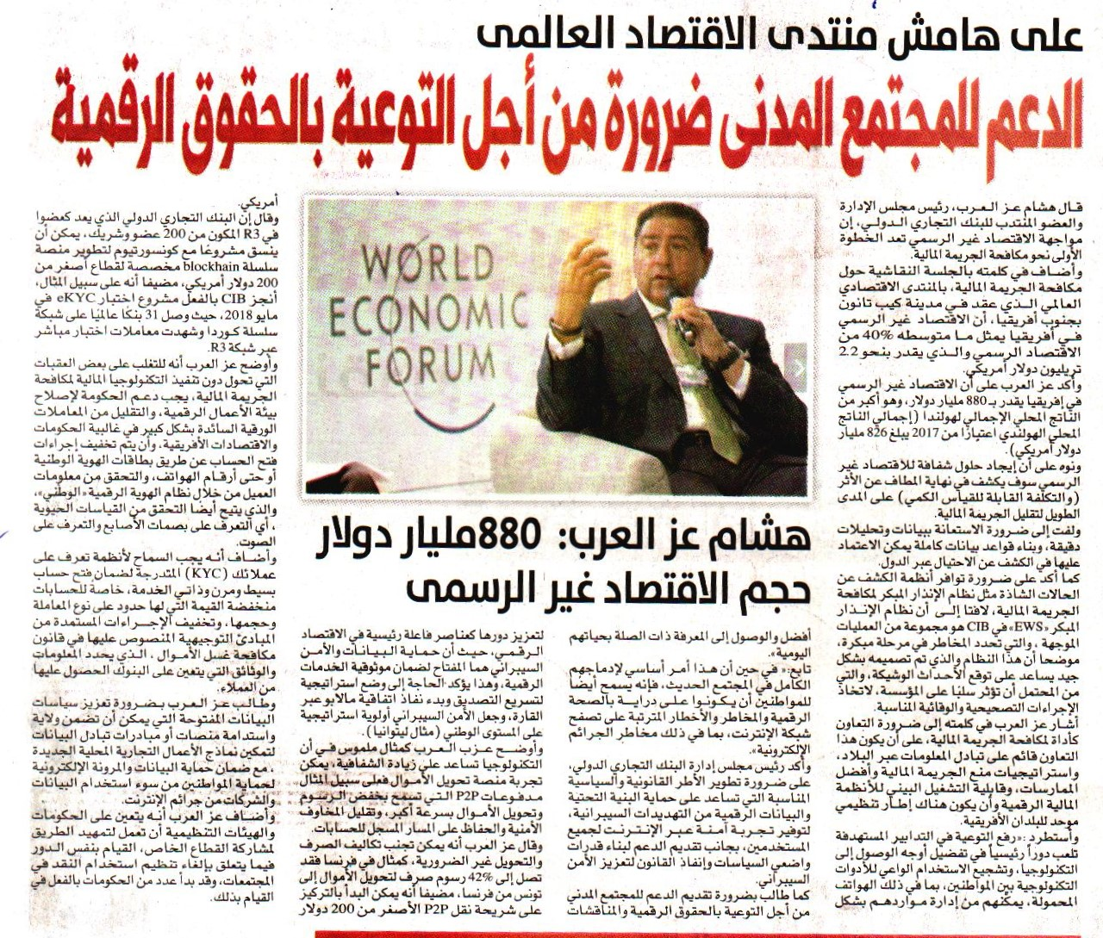

Publication | Al Mal |  |  |  |  |  |  | Circulation |  | 200,000
Date: | 09- September -2019 |  |  |  |  |  |  | Frequency |  | Daily
Page (s) | 07
Placement Rating | -2 | -2 | -1 | -2 | -1 |  | 0 |  | +1 |  | +2 | +1 | +2 | +2
 | Premium Page | Quote | Picture | Name in Headline |  | Branded | Not Branded |  | Branded |  | Name in Headline | Picture | Quote | Premium Page
Publication’s Rating | A B C
Impact | +7A
Headline

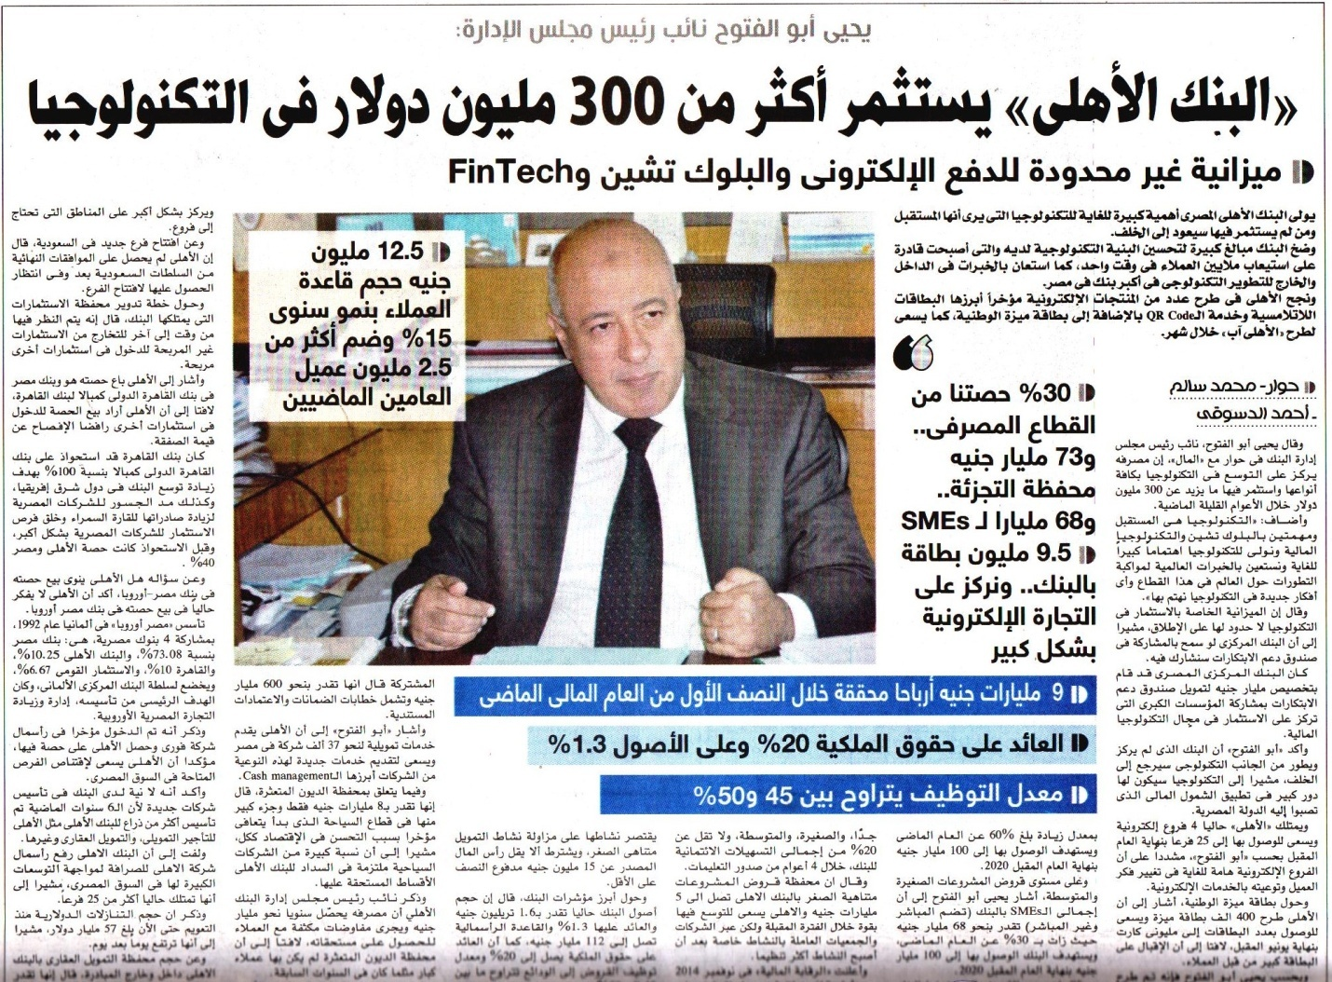
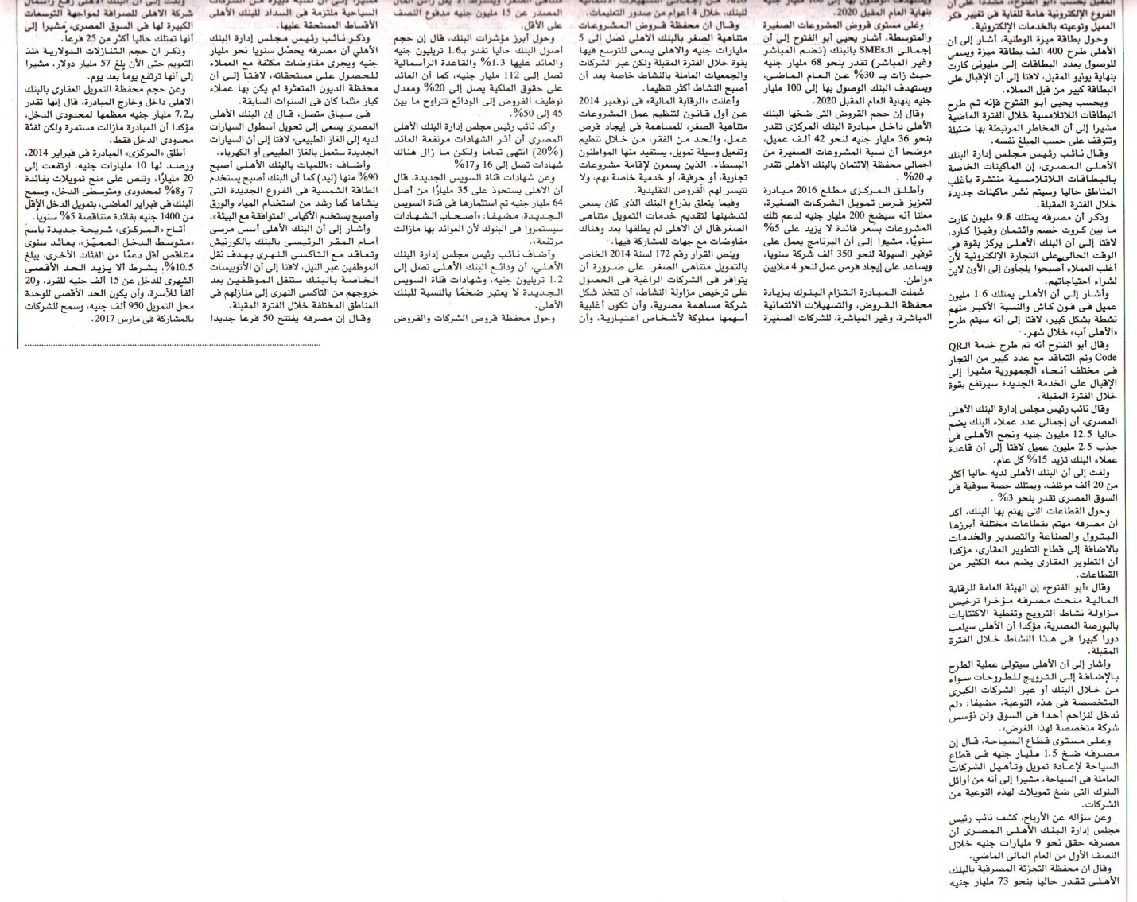

Publication | Al Mal |  |  |  |  |  |  | Circulation |  | 200,000
Date: | 09- September -2019 |  |  |  |  |  |  | Frequency |  | Daily
Page (s) | 05
Placement Rating | -2 | -2 | -1 | -2 | -1 |  | 0 |  | +1 |  | +2 | +1 | +2 | +2
 | Premium Page | Quote | Picture | Name in Headline |  | Branded | Not Branded |  | Branded |  | Name in Headline | Picture | Quote | Premium Page
Publication’s Rating | A B C
Impact | +7A
Headline

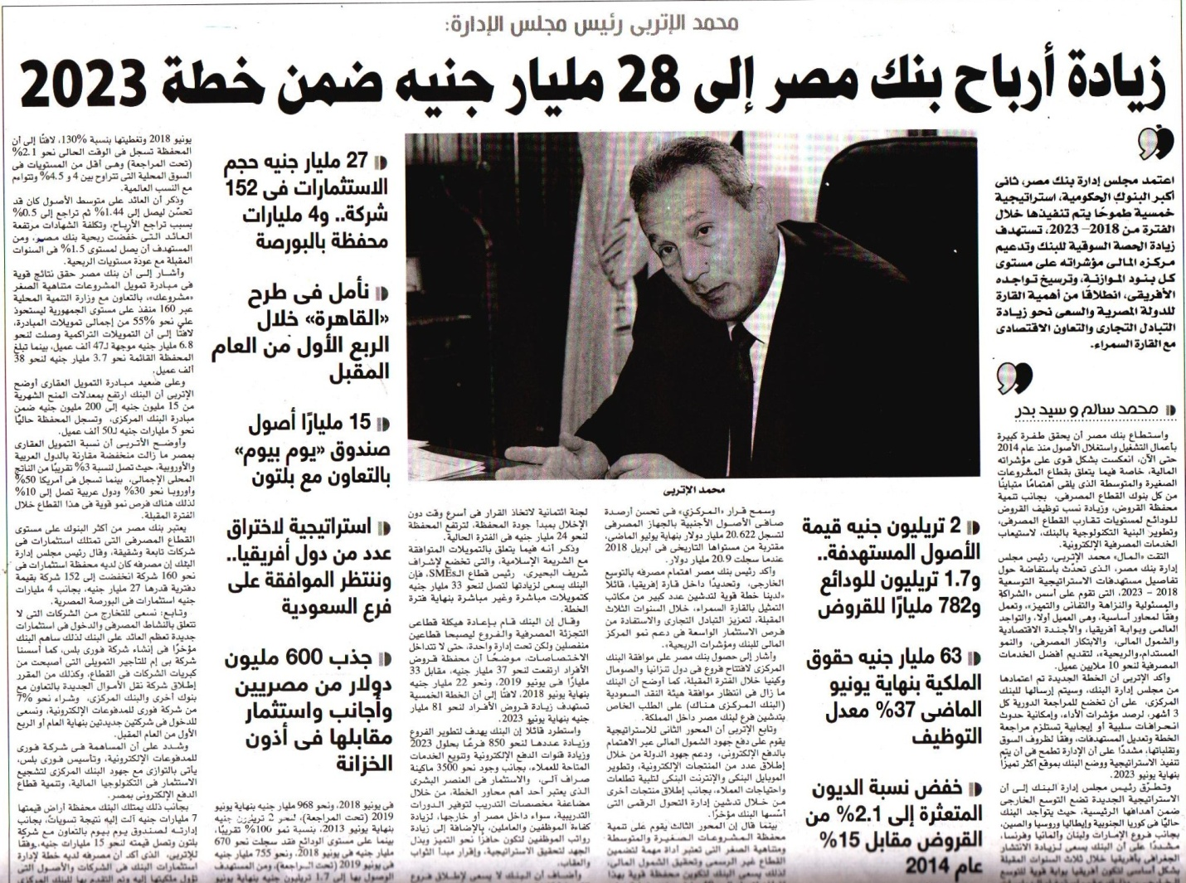
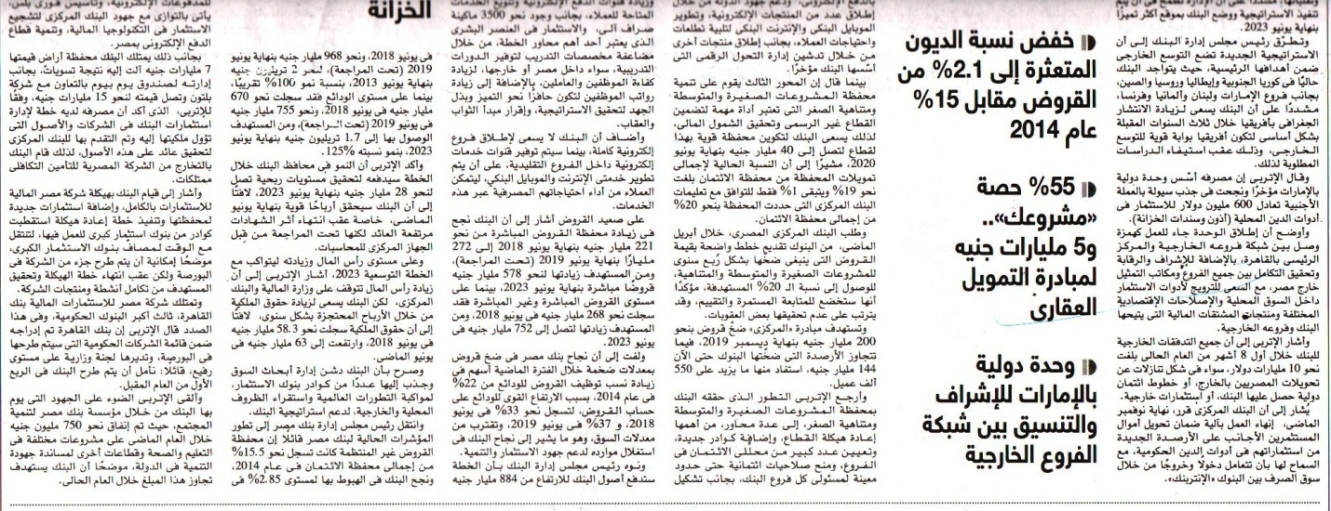

Publication | Al Mal |  |  |  |  |  |  | Circulation |  | 200,000
Date: | 09- September -2019 |  |  |  |  |  |  | Frequency |  | Daily
Page (s) | 06
Placement Rating | -2 | -2 | -1 | -2 | -1 |  | 0 |  | +1 |  | +2 | +1 | +2 | +2
 | Premium Page | Quote | Picture | Name in Headline |  | Branded | Not Branded |  | Branded |  | Name in Headline | Picture | Quote | Premium Page
Publication’s Rating | A B C
Impact | +7A
Headline

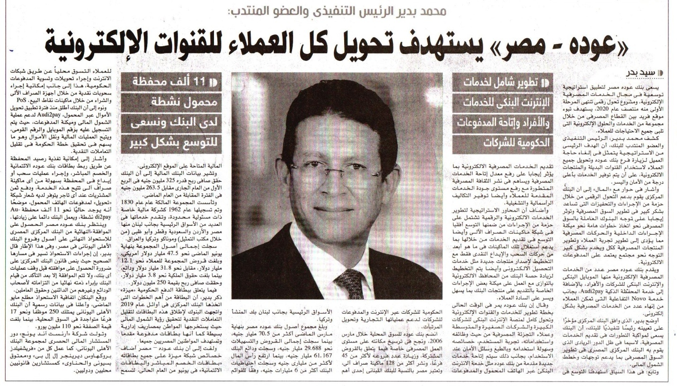

Publication | Al Mal |  |  |  |  |  |  | Circulation |  | 200,000
Date: | 09- September -2019 |  |  |  |  |  |  | Frequency |  | Daily
Page (s) | 09
Placement Rating | -2 | -2 | -1 | -2 | -1 |  | 0 |  | +1 |  | +2 | +1 | +2 | +2
 | Premium Page | Quote | Picture | Name in Headline |  | Branded | Not Branded |  | Branded |  | Name in Headline | Picture | Quote | Premium Page
Publication’s Rating | A B C
Impact | +7A
Headline

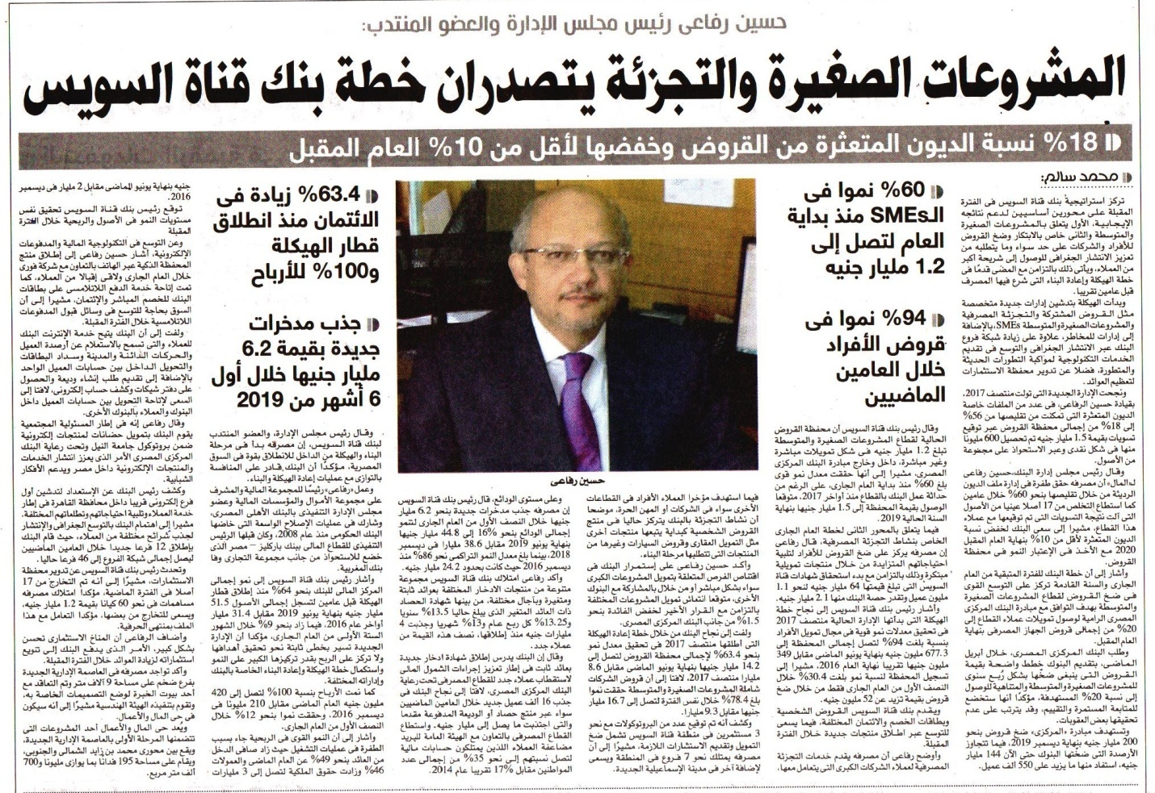

Publication | Al Wafd |  |  |  |  |  |  | Circulation |  | 30,000
Date: | 09- September -2019 |  |  |  |  |  |  | Frequency |  | Daily
Page (s) | 06
Placement Rating | -2 | -2 | -1 | -2 | -1 |  | 0 |  | +1 |  | +2 | +1 | +2 | +2
 | Premium Page | Quote | Picture | Name in Headline |  | Branded | Not Branded |  | Branded |  | Name in Headline | Picture | Quote | Premium Page
Publication’s Rating | A B C
Impact | +7A
Headline

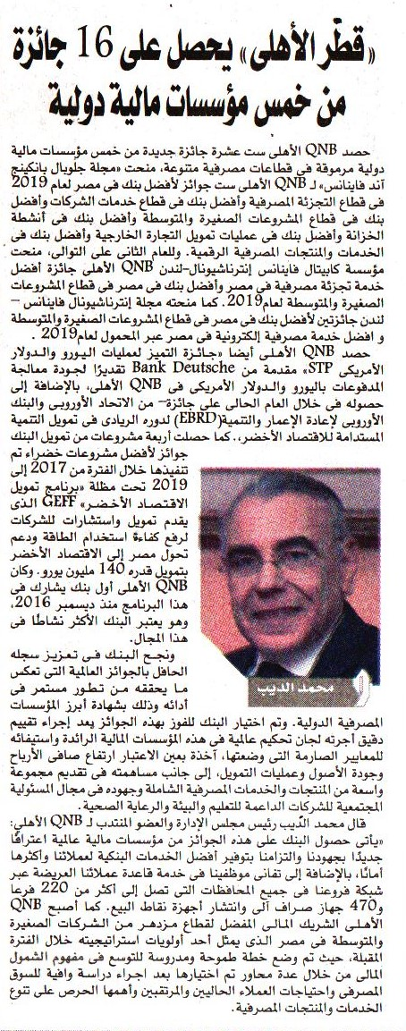

Publication | Al Wafd |  |  |  |  |  |  | Circulation |  | 30,000
Date: | 09- September -2019 |  |  |  |  |  |  | Frequency |  | Daily
Page (s) | 09
Placement Rating | -2 | -2 | -1 | -2 | -1 |  | 0 |  | +1 |  | +2 | +1 | +2 | +2
 | Premium Page | Quote | Picture | Name in Headline |  | Branded | Not Branded |  | Branded |  | Name in Headline | Picture | Quote | Premium Page
Publication’s Rating | A B C
Impact | +7A
Headline



Publication | Al Watan |  |  |  |  |  |  | Circulation |  | 100,000
Date: | 09- September -2019 |  |  |  |  |  |  | Frequency |  | Daily
Page (s) | 01
Placement Rating | -2 | -2 | -1 | -2 | -1 |  | 0 |  | +1 |  | +2 | +1 | +2 | +2
 | Premium Page | Quote | Picture | Name in Headline |  | Branded | Not Branded |  | Branded |  | Name in Headline | Picture | Quote | Premium Page
Publication’s Rating | A B C
Impact | +6A
Headline

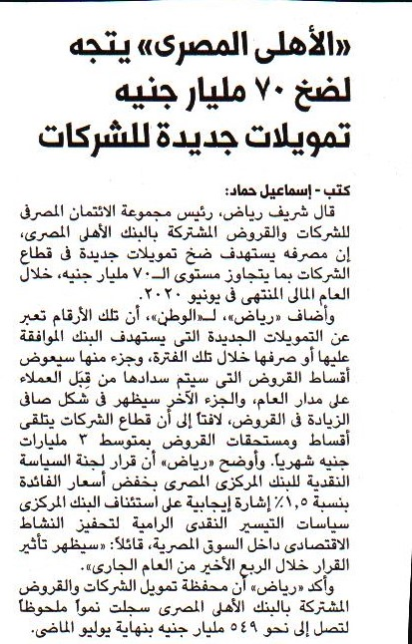

Publication | Daily News |  |  |  |  |  |  | Circulation |  | 80,000
Date: | 09- September -2019 |  |  |  |  |  |  | Frequency |  | Daily
Page (s) | 06
Placement Rating | -2 | -2 | -1 | -2 | -1 |  | 0 |  | +1 |  | +2 | +1 | +2 | +2
 | Premium Page | Quote | Picture | Name in Headline |  | Branded | Not Branded |  | Branded |  | Name in Headline | Picture | Quote | Premium Page
Publication’s Rating | A B C
Impact | +7A
Headline

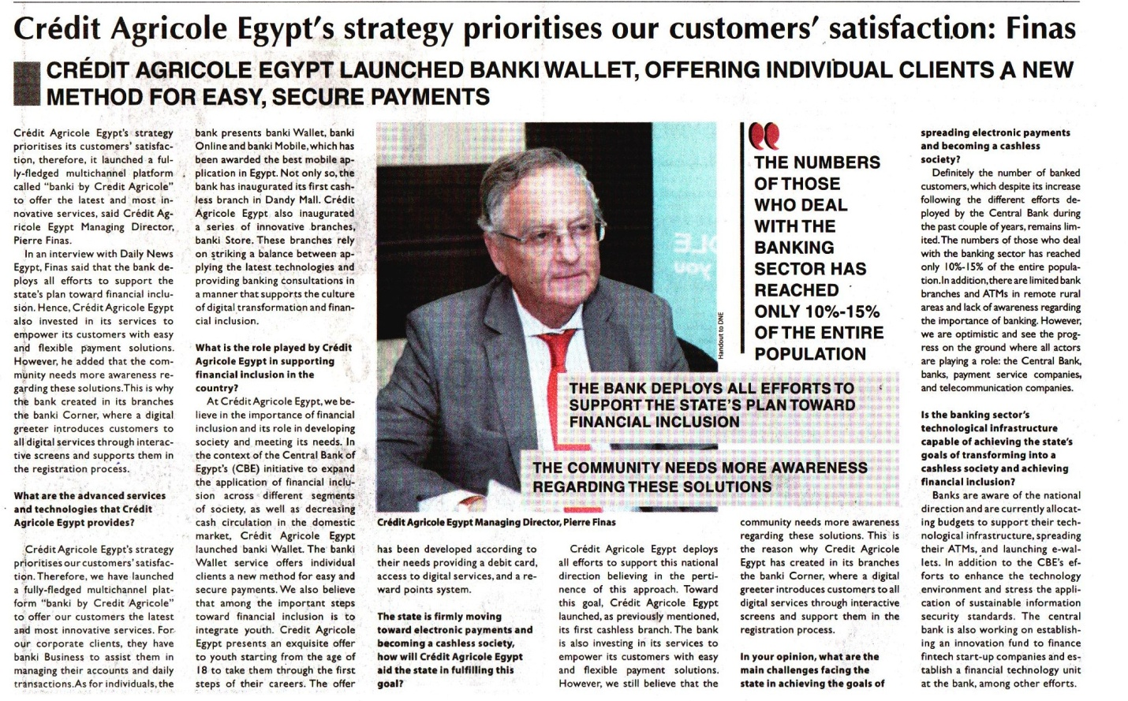

Publication | Daily News |  |  |  |  |  |  | Circulation |  | 80,000
Date: | 09- September -2019 |  |  |  |  |  |  | Frequency |  | Daily
Page (s) | 06
Placement Rating | -2 | -2 | -1 | -2 | -1 |  | 0 |  | +1 |  | +2 | +1 | +2 | +2
 | Premium Page | Quote | Picture | Name in Headline |  | Branded | Not Branded |  | Branded |  | Name in Headline | Picture | Quote | Premium Page
Publication’s Rating | A B C
Impact | +7A
Headline

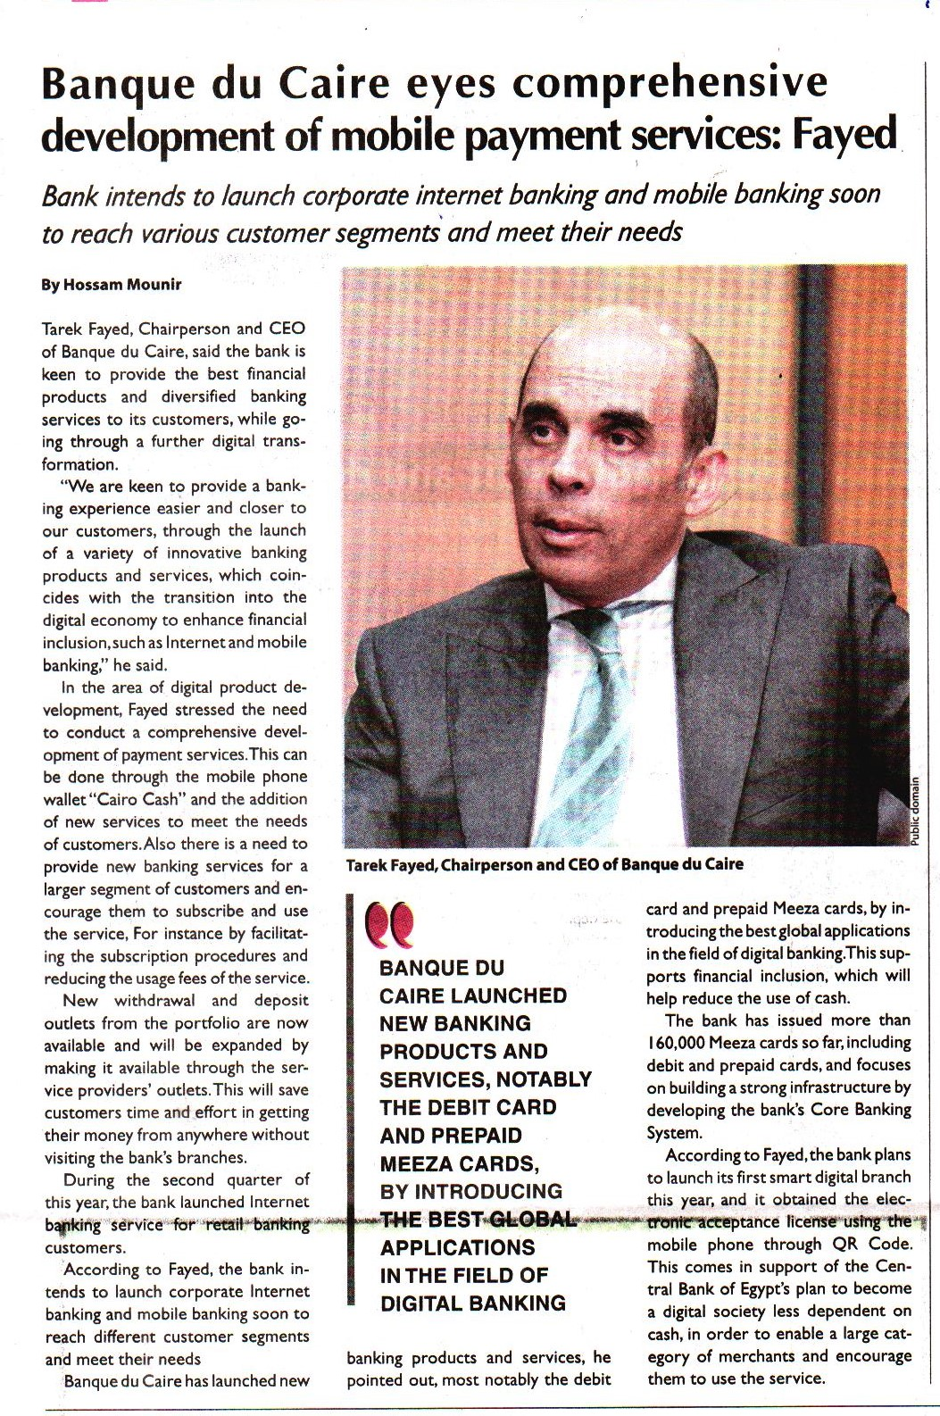

Publication | Daily News |  |  |  |  |  |  | Circulation |  | 80,000
Date: | 09- September -2019 |  |  |  |  |  |  | Frequency |  | Daily
Page (s) | 08
Placement Rating | -2 | -2 | -1 | -2 | -1 |  | 0 |  | +1 |  | +2 | +1 | +2 | +2
 | Premium Page | Quote | Picture | Name in Headline |  | Branded | Not Branded |  | Branded |  | Name in Headline | Picture | Quote | Premium Page
Publication’s Rating | A B C
Impact | +7A
Headline

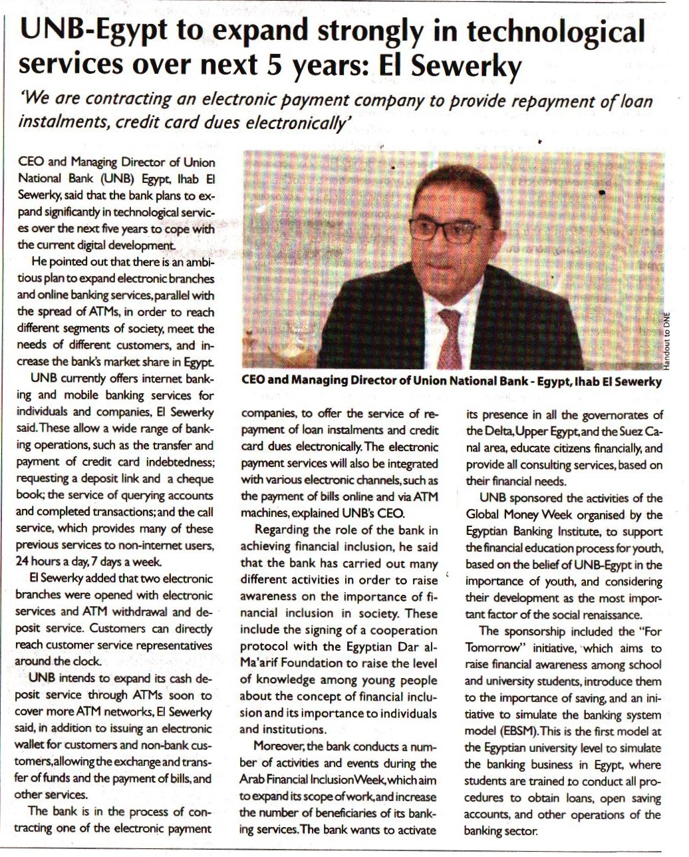
Publication | Daily News |  |  |  |  |  |  | Circulation |  | 80,000
Date: | 09- September -2019 |  |  |  |  |  |  | Frequency |  | Daily
Page (s) | 08
Placement Rating | -2 | -2 | -1 | -2 | -1 |  | 0 |  | +1 |  | +2 | +1 | +2 | +2
 | Premium Page | Quote | Picture | Name in Headline |  | Branded | Not Branded |  | Branded |  | Name in Headline | Picture | Quote | Premium Page
Publication’s Rating | A B C
Impact | +7A
Headline

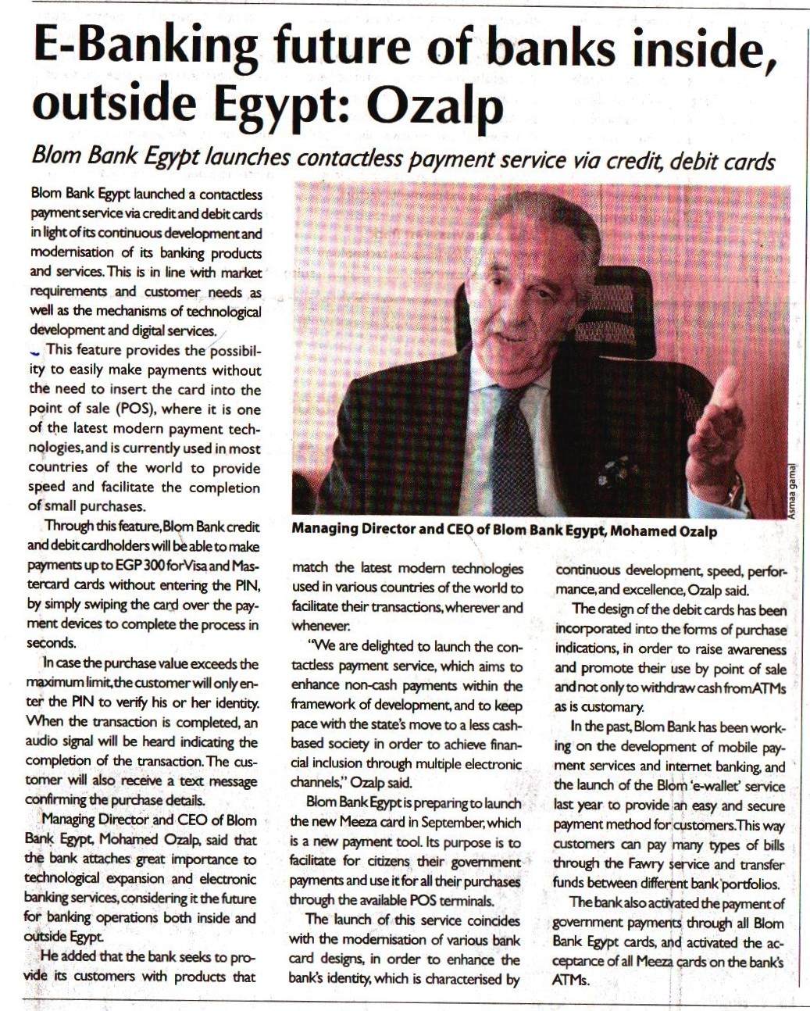
Publication | Daily News |  |  |  |  |  |  | Circulation |  | 80,000
Date: | 09- September -2019 |  |  |  |  |  |  | Frequency |  | Daily
Page (s) | 08
Placement Rating | -2 | -2 | -1 | -2 | -1 |  | 0 |  | +1 |  | +2 | +1 | +2 | +2
 | Premium Page | Quote | Picture | Name in Headline |  | Branded | Not Branded |  | Branded |  | Name in Headline | Picture | Quote | Premium Page
Publication’s Rating | A B C
Impact | +7A
Headline

